1. 測試內容：

測試L2 Rewrite“ETH_DST”是否正確運行。

1. 測試環境架構：

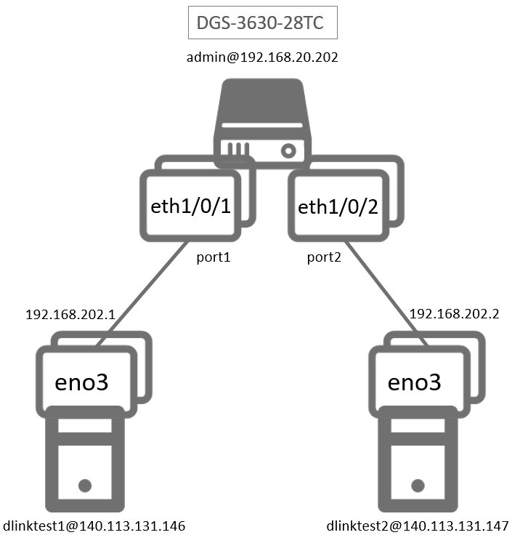

1. 測試環境組態：

* SDN controller: ONOS 1.15.0
* Switch: DGS-3630
* Hosts:
  + ubuntu 16.04.5 LTS
  + dlinktest1(實體機)
    - IP: 192.168.202.1
    - MAC: d0:94:66:5d:5e:08/64
    - Port: 1
  + dlinktest2(實體機)
    - IP: 192.168.202.2
    - MAC: d0:94:66:5c:45:20/64
    - Port: 2
* Apps:

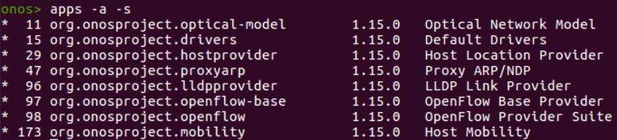

1. 使用之JSON文件：
   * Flow Rule: (附檔：flowInPort.json)
     + Match Flow: 若封包從port 1進入則將封包送到GROUP ID為268500994的table。

|  |
| --- |
| {  "flows": [  {  "priority": 100,  "timeout": 0,  "isPermanent": true,  "deviceId": "of:000078321bdf4000",  "treatment": {  "instructions": [],  "deferred":[  {  "type": "GROUP",  "groupId": 268500994  }  ]  },  "selector": {  "criteria": [  {  "type": "IN_PORT",  "port": "1"  }  ]  }  }  ]  } |

* + Group Rule: (附檔：groupEthDst.json)
    - 將ETH_DST改成d0:94:66:5c:45:1f。

|  |
| --- |
| {  "type": "INDIRECT",  "appCookie": "0x2234abc3",  "groupId": 268500994,  "buckets": [{  "treatment": {  "instructions": [  {  "type": "L2MODIFICATION",  "subtype": "ETH_DST",  "mac": "d0:94:66:5c:45:1f"  },  {  "type": "GROUP",  "groupId": 65538  }  ]  }  }]  } |

* + Group Rule: (附檔：group.json)
    - 將封包output到port 2。

|  |
| --- |
| {  "type": "INDIRECT",  "appCookie": "0x1234abc3",  "groupId": 65538,  "buckets": [{  "treatment": {  "instructions": [{  "type": "OUTPUT",  "port": 2  }]  }  }]  } |

1. 測試步驟：
2. ONOS GUI

* Flow View：



* Group View：



1. Monitor: Using ping tool

* Let h1 ping h2.

|  |
| --- |
| ping 192.168.202.2 –c 5 |

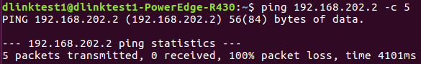

* h1 uses tcpdump to monitor.

|  |
| --- |
| sudo tcpdump –i eno3 –e icmp |

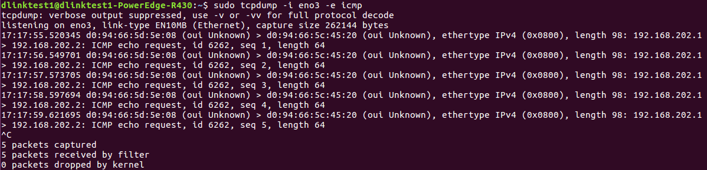

* h2 uses tcpdump to monitor.

|  |
| --- |
| sudo tcpdump –i eno3 –e icmp |

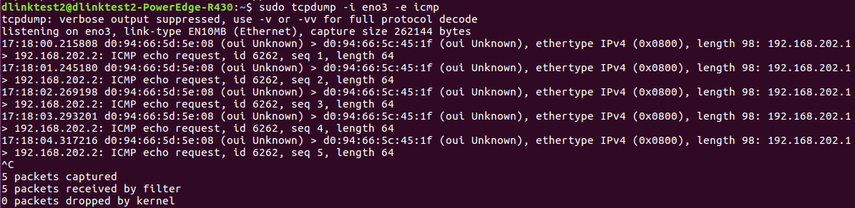

* 從上兩張圖可以看到EthDst從d0:94:66:5c:45:20順利改成d0:94:66:5c:45:1f。

1. Monitor: Switch CLI

* Show group entries.

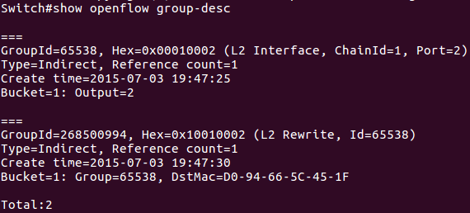

* Show flow entries related to group entries.

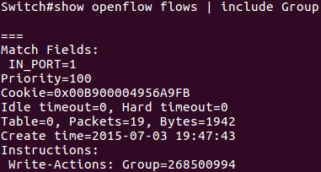

1. Monitor: ONOS CLI

* Show group entries.

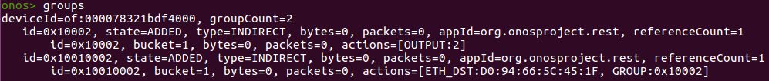

* Show flow entries related to group entries.



1. 測試結果：

L2 Rewrite“ETH_DST”可以正確運行。